1. Переключитесь на платформу Android
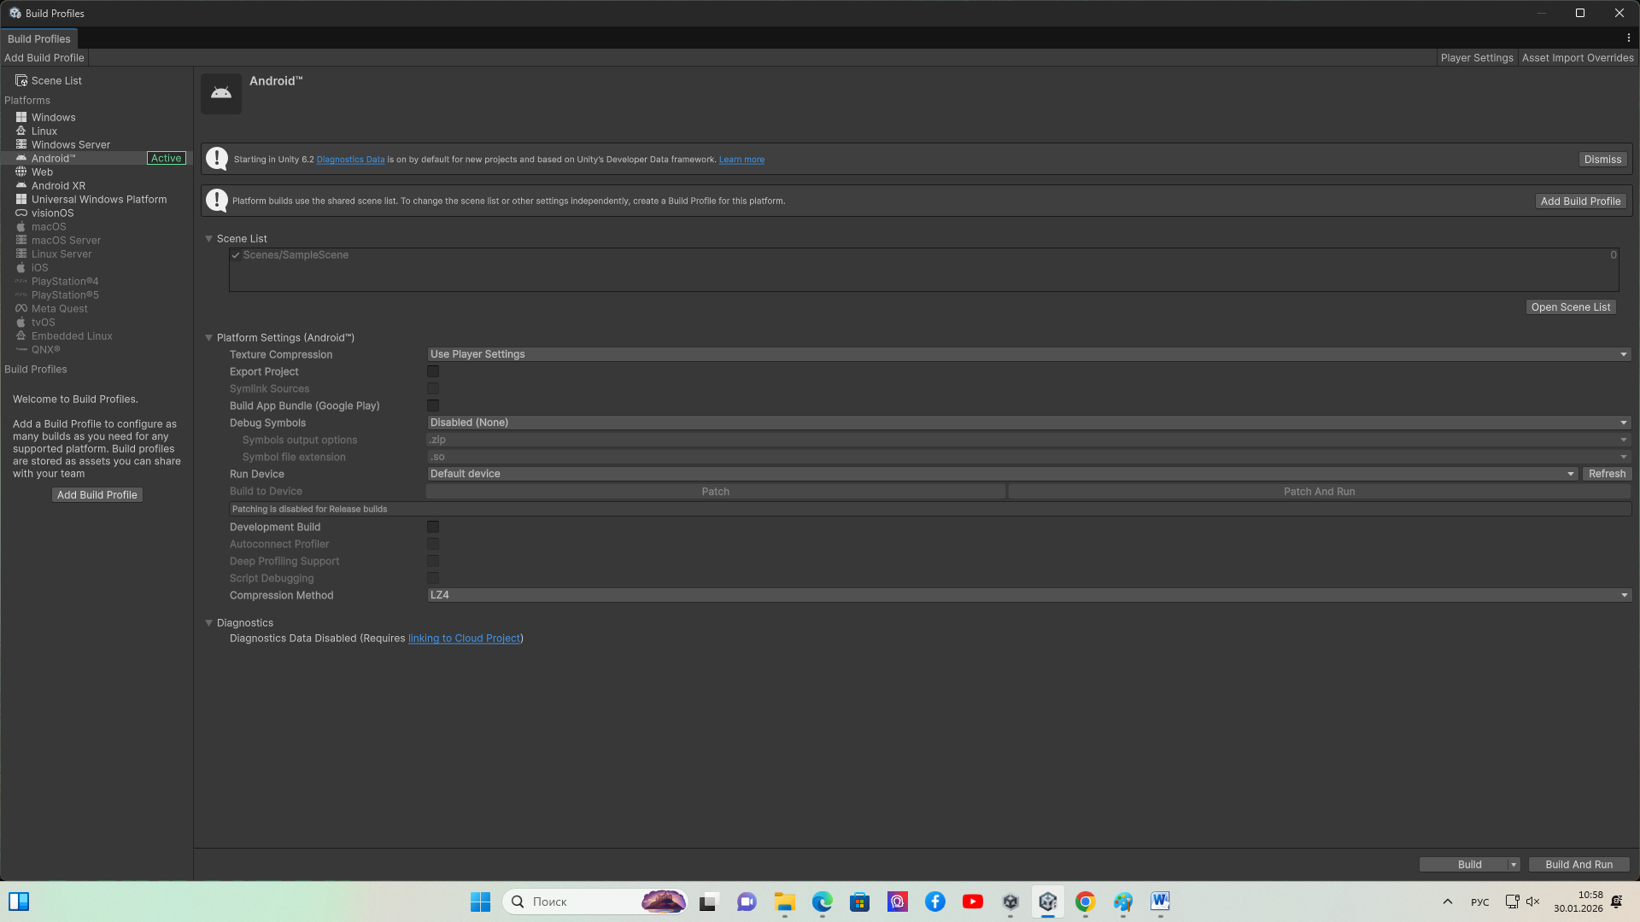
2. Настройте плагин XChart. Для этого скачайте unitypackage https://github.com/XCharts-Team/XCharts/releases?spm=a2ty_o01.29997173.0.0.4097517105zzRi на любую папку ПК
3. Выполните команду Asset-ImportPackage - CustomPackage
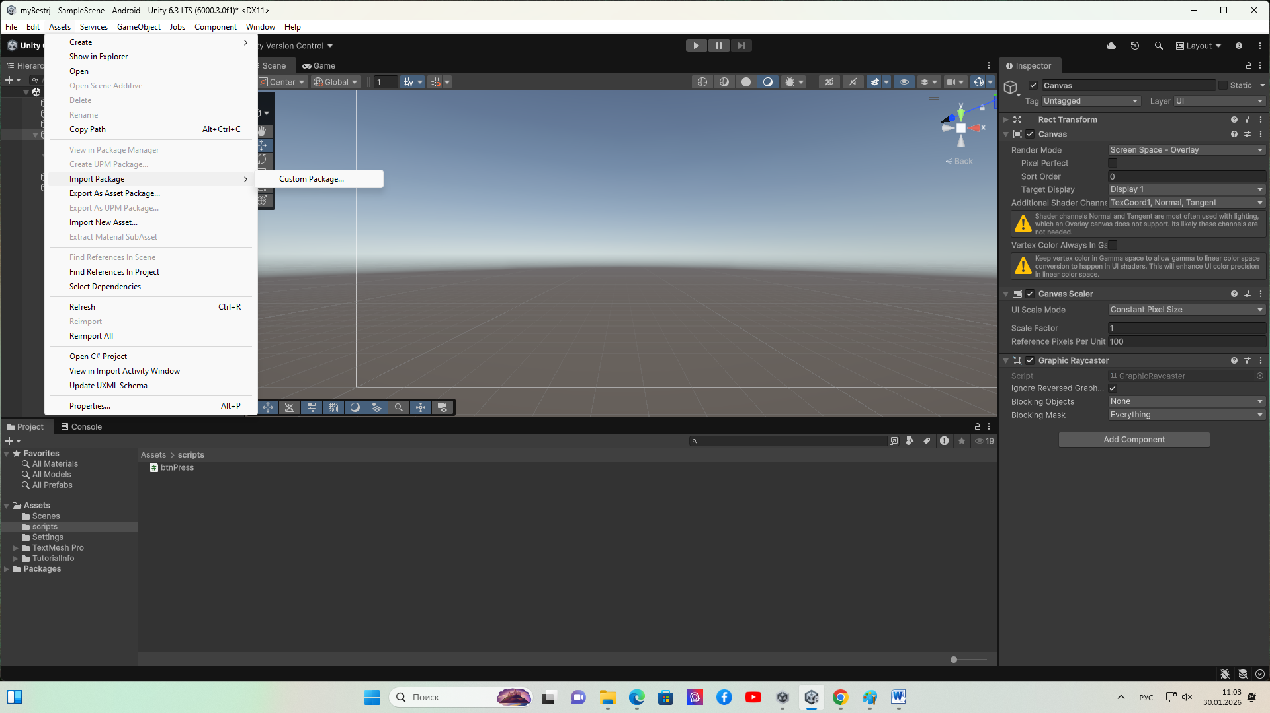
4. Выберете путь к вашему файлу.
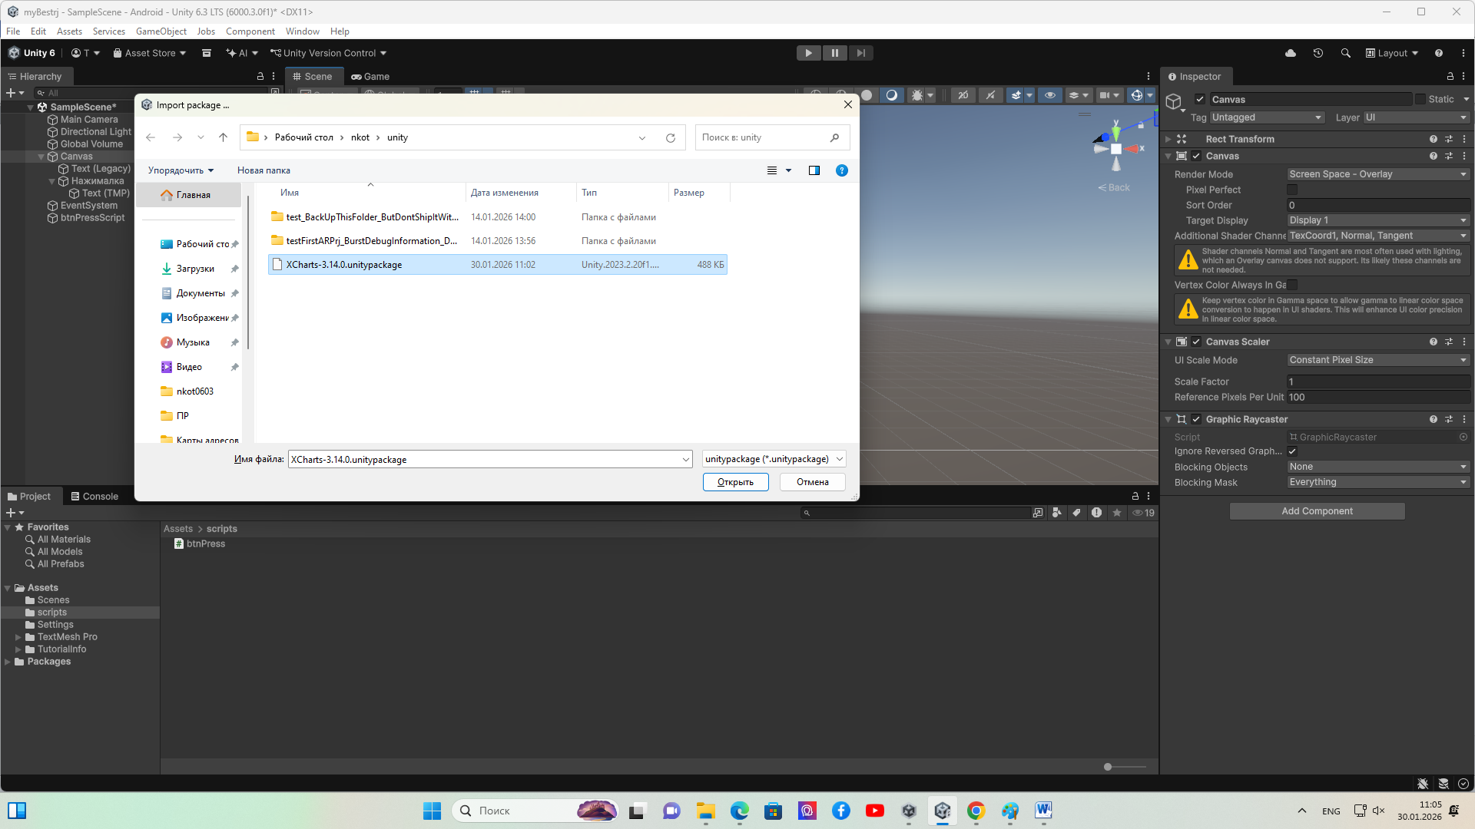
5. Сделайте импорт пакетов
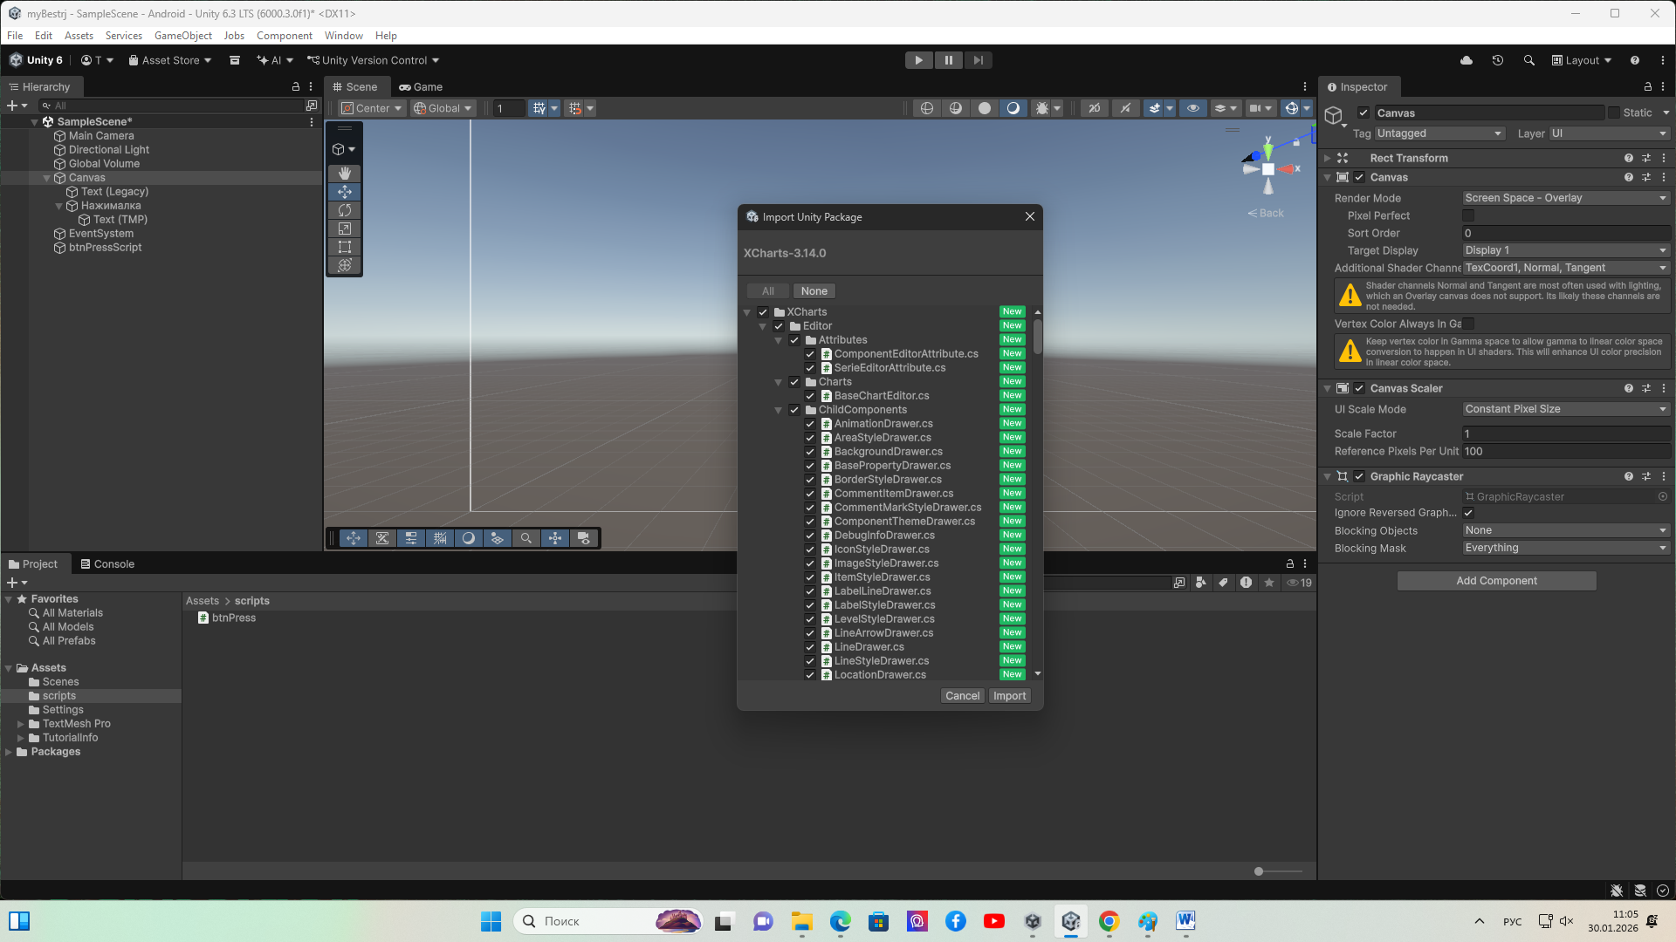
6. скачать nugget for unity
https://github.com/GlitchEnzo/NuGetForUnity/releases?spm=a2ty_o01.29997173.0.0.4097517105zzRi
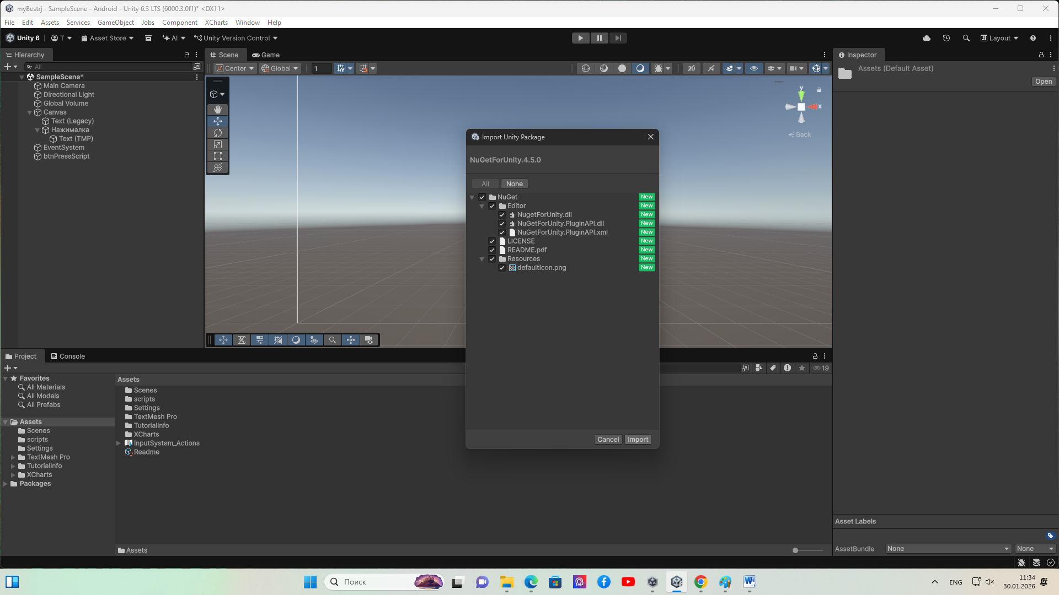
Откройте nuget – manage NuGetPackages
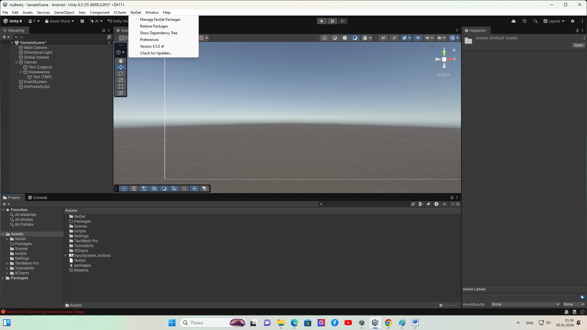
Найдите и установите MQTTnet! Важно!!! Предварительно выбрать версию 3.1.2.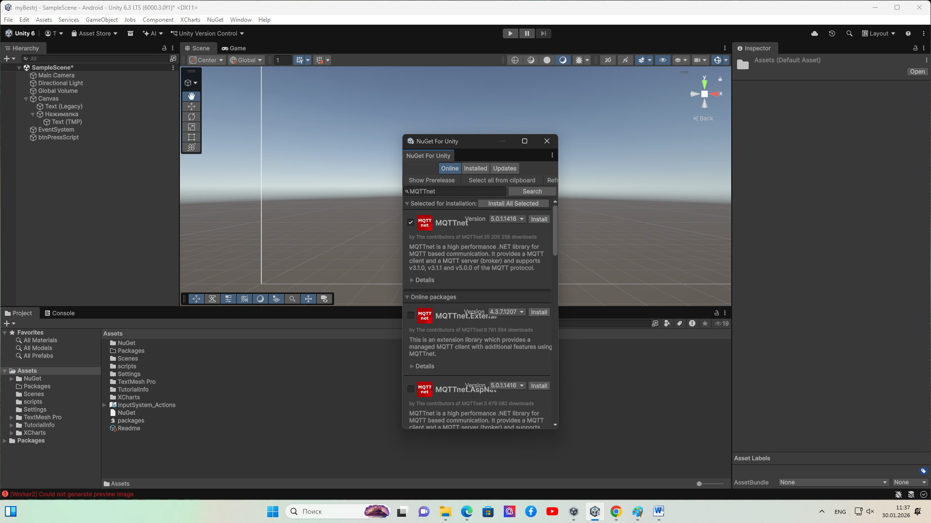
Добавьте скрипт MqttChartScript в папку assets/scripts
using MQTTnet;
using MQTTnet.Client;
using MQTTnet.Client.Options;
using UnityEngine;
using System.Text;
using XCharts.Runtime;
using System.Collections;
using System.Collections.Generic;

using XCharts;
using System; // Import XCharts namespace

public class MqttChartScript : MonoBehaviour
{
private IMqttClient _mqttClient;
public LineChart chart; // Reference to the XCharts LineChart component

[Header("MQTT Broker Settings")]
public string brokerAddress = "10.0.0.50"; // Replace with your broker address
public int brokerPort = 1883; // Default MQTT port
public string topic; // Replace with your topic
//List<GameObject> lineList = new List<GameObject>();

public int i;

async void Start()
{
// Create MQTT client
var factory = new MqttFactory();
_mqttClient = factory.CreateMqttClient();

// Configure options
var options = new MqttClientOptionsBuilder()
.WithTcpServer(brokerAddress, brokerPort)
.Build();

// Connect to broker
await _mqttClient.ConnectAsync(options);

if (_mqttClient.IsConnected)
{
Debug.Log("Connected to MQTT broker");

// Subscribe to topic
await _mqttClient.SubscribeAsync(new MqttTopicFilterBuilder().WithTopic(topic).Build());
Debug.Log($"Subscribed to topic: {topic}");
}
else
{
Debug.LogError("Failed to connect to MQTT broker");
}

// Register message handler
_mqttClient.UseApplicationMessageReceivedHandler(e =>
{
string message = Encoding.UTF8.GetString(e.ApplicationMessage.Payload);
Debug.Log($"Received message: {message}");

// Process the message (e.g., update chart)
OnMessageReceived(message);
});
}

void OnMessageReceived(string message)
{
// Parse the message (assuming it's a numeric value)
if (float.TryParse(message, out float value))
{
// Update the chart with the new value
UpdateChart(value);
}
else
{
Debug.LogError("Received message is not a valid number");
}
}

void UpdateChart(float value)
{
var dateTime = DateTime.Now;
string time = dateTime.Hour + ":" + dateTime.Minute + ":" + dateTime.Second;
// Add the new value to the chart
chart.AddXAxisData(time);
chart.AddData(0, value); // Assuming you're using the first series (index 0)
//chart.AddData(0, new Vector2(0.1f,int.Parse(value.ToString("0.0"))));

// Optional: Limit the number of data points to keep the chart clean
if (chart.series[0].dataCount > 2000)
{
chart.series[0].RemoveData(0);
}
}

async void OnDestroy()
{
if (_mqttClient != null && _mqttClient.IsConnected)
{
await _mqttClient.DisconnectAsync();
Debug.Log("Disconnected from MQTT broker");
}
}
}

Добавьте LineChart –Time
И настройте
